I tried to create a function app (precompiled and on azure portal both) and I am connecting using mySQL client  class which we get in nuget  package by  “Install-Package MySql.Data”

**Steps for precompiled function app :**

1. Sample code in function :

|  |
| --- |
| 1. using System; 2. using Microsoft.Azure.WebJobs; 3. using Microsoft.Azure.WebJobs.Host; 4. using MySql.Data.MySqlClient; 5. namespace FunctionAppMySQL 6. { 7. public static class MySQLConnector 8. { 9. [FunctionName("MySQLConnector")] 10. public static void Run([TimerTrigger("0 */5 * * * *")]TimerInfo myTimer, TraceWriter log) 11. { 12. log.Info($"C# Timer trigger function executed at: {DateTime.Now}"); 13. var server = "mysql-118671.srv.hoster.ru"; 14. var Userid = "xxxx_111"; 15. var Password = "xxxx@12"; 16. string connstring = string.Format("Server={0}; UID={1}; password={2}", server, Userid, Password); 17. MySqlConnection conn = new MySqlConnection(connstring); 18. try 19. { 20. conn.Open(); 21. log.Info($"success connection : {DateTime.Now}"); 22. } 23. catch (Exception ex) 24. { 25. log.Info($"failed connection : {DateTime.Now}"); 26. log.Info($"failed connection : {ex.Message.ToString()}"); 27. } 28. } |

2. install package for MySql using nuget package manager  **Install-Package MySql.Data**

3. Deployed this function app from visual studio on azure portal using publish option.

4. This could connect to mySQL database.

Steps to make it work on non-precompiled Function app :

1. Sample Code inside function :

Here is the sample code which I am using for inline C# function app in Portal :

|  |
| --- |
| #r "D:\home\site\wwwroot\TimerTriggerCSharp1\System.Data.dll"  #r "D:\home\site\wwwroot\TimerTriggerCSharp1\MySql.Data.dll"  using System;  using MySql.Data.MySqlClient;  using System.Data;  public static void Run(TimerInfo myTimer, TraceWriter log)  {      log.Info($"C# Timer trigger function executed at: {DateTime.Now}");           var server = "mysql-xxxx.srv.hoster.ru";           var Userid = "xxx_111";           var Password = "xxxx@12";               string connstring = string.Format("Server={0}; UID={1}; password={2}", server, Userid, Password);                MySqlConnection  conn = new MySqlConnection(connstring);                  try                  {                      conn.Open();                      log.Info($"success connection : {DateTime.Now}");                  }                  catch (Exception ex)                  {                        log.Info($"failed connection : {DateTime.Now}");                      log.Info($"failed connection : {ex.Message.ToString()}");              }  } |

1. Copy the System.Data.dll  & MySql.Data.dll  dlls into function via KUDU :

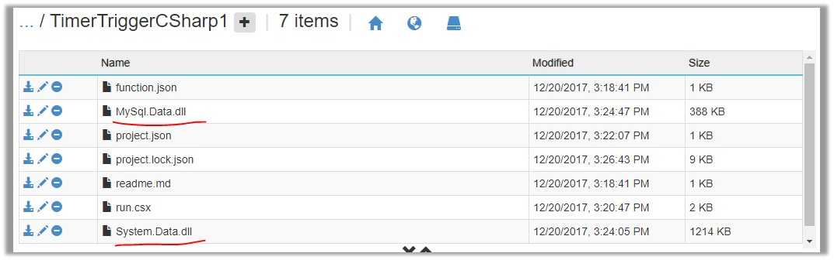

1. Try to run the function, if it doesn’t work and says that dll loading failed , then try to use project.json file like this :

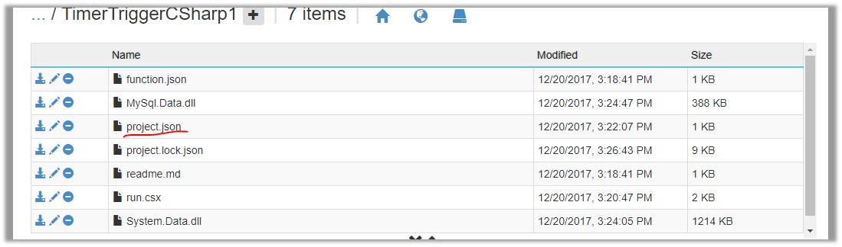

1. Inside that project.json file , write following :

|  |
| --- |
| 1. { 2. "frameworks": { 3. "net46":{ 4. "dependencies": { 5. "MySql.Data": "6.10.5" 6. } 7. } 8. } 9. } |

Above both ways working fine for me and I could connect to mySQL database.

If you are looking specifically for ODBC connection string then , you don’t need to write DRIVER=MySQL ODBC 5.3 Unicode Driver; or use the driver version 6.3 or 6.5 and try.